Screen shots of this Weather App - May 16, 2016

==================================================

App started:

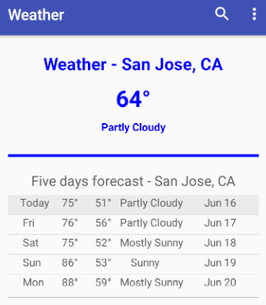

======================================================

- After Search-Icon clicked in App-bar and user typed Miami, Florida in App-bar:

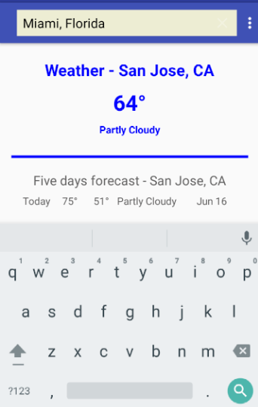

===============================================

Weather for Miami is shown:



